**Technical Lab Test – S3 Innovate Bangladesh**

**Applicant Name:Mahmudul Hassan Rokive**

**Job Title: Senior Software Engineer (.Net)**

1. Build a single page application (spa)crud operation using dot net/dot net core framework in back-end and AngularJS/Angular in front-end.

Create Page

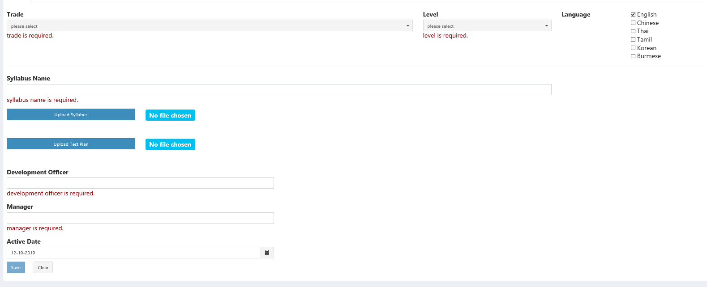

List Page

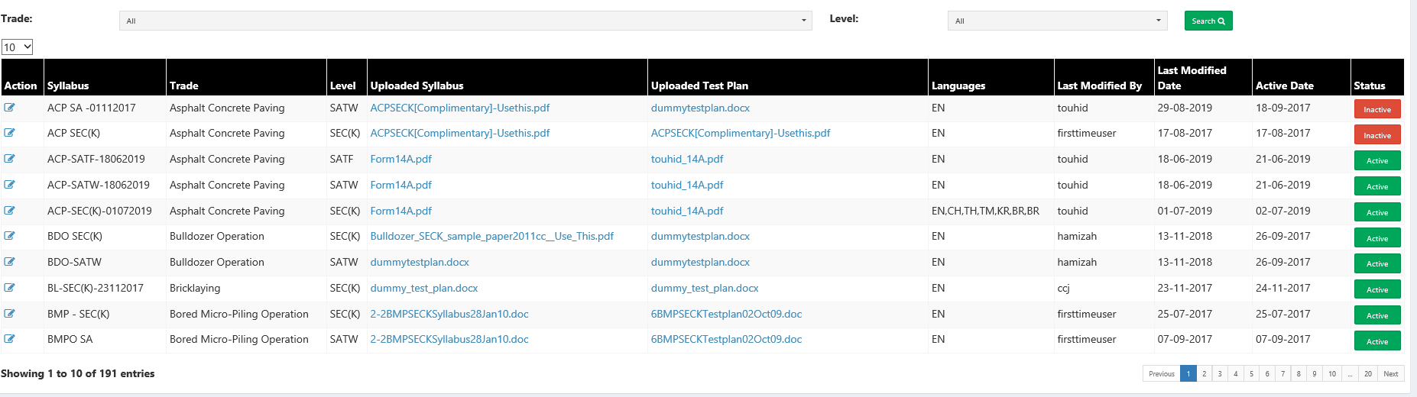

1. Calculate mobile bill between two date times.

Peak Hour: 9.00 am to 10.59 pm

20 second pulse and each pulse rate 30 paisa

Off-peak Hour: 12.00 am to 8.59 am and 11.00 pm to 11.59 pm

20 second pulse and each pulse rate 20 paisa

Note: If pulse overlap (peak to off-peak or off-peak to peak) then take peak hour rate.

Sample input:

Start time: 2019-08-31 08:59:13 am

End time: 2019-08-31 09:00:39 am

Breakdown:

2019-09-31 08:59:13 + 20 second (2019-09-31 08:59:33) = 20 paisa

2019-09-31 08:59:34 + 20 second (2019-09-31 08:59:54) = 20 paisa

2019-09-31 08:59:55 + 20 second (2019-09-31 09:00:15) = 30 paisa

2019-09-31 09:00:16 + 20 second (2019-09-31 09:00:36) = 30 paisa

2019-09-31 09:00:37+ 3 second (2019-09-31 09:00:39) = 30 paisa

Sample output: 1.3 taka